Spring Scheduling

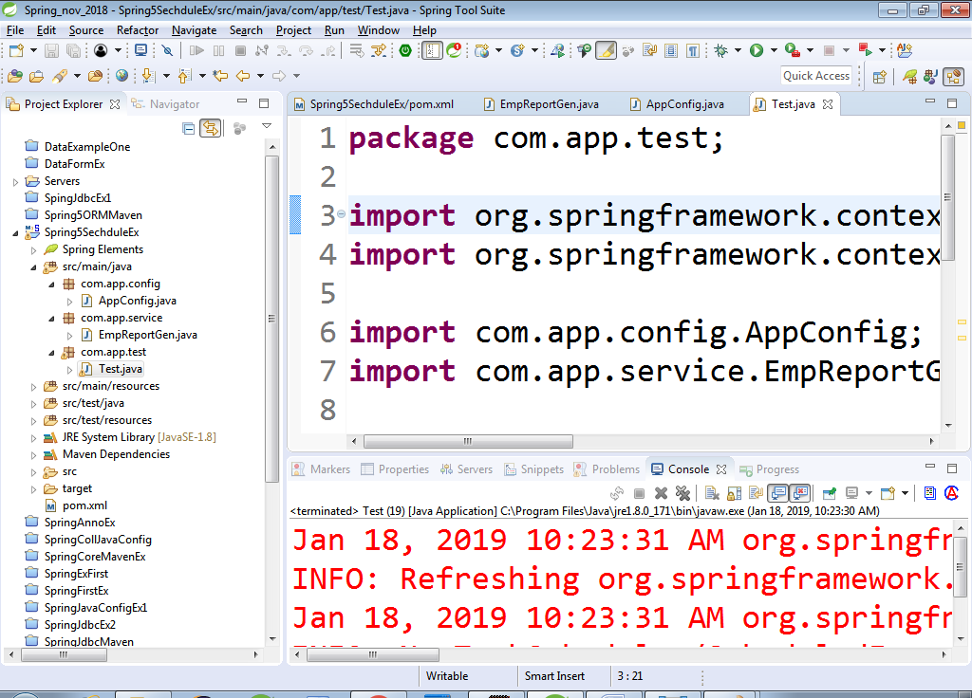

**pom.xml:-**

<project xmlns=*"http://maven.apache.org/POM/4.0.0"*

xmlns:xsi=*"http://www.w3.org/2001/XMLSchema-instance"*

xsi:schemaLocation=*"http://maven.apache.org/POM/4.0.0 http://maven.apache.org/xsd/maven-4.0.0.xsd"*>

<modelVersion>4.0.0</modelVersion>

<groupId>org.sathyatech</groupId>

<artifactId>Spring5SechduleEx</artifactId>

<version>1.0</version>

<dependencies>

<dependency>

<groupId>org.springframework</groupId>

<artifactId>spring-context</artifactId>

<version>5.0.6.RELEASE</version>

</dependency>

</dependencies>

<build>

<plugins>

<plugin>

<groupId>org.apache.maven.plugins</groupId>

<artifactId>maven-compiler-plugin</artifactId>

<version>3.8.0</version>

<configuration>

<source>1.8</source>

<target>1.8</target>

</configuration>

</plugin>

</plugins>

</build>

</project>

**AppConfig.java:-**

**package** com.app.config;

**import** org.springframework.context.annotation.ComponentScan;

**import** org.springframework.context.annotation.Configuration;

**import** org.springframework.scheduling.annotation.EnableScheduling;

@Configuration

@EnableScheduling

@ComponentScan(basePackages="com.app")

**public** **class** AppConfig {

}

**Service class:-**

**package** com.app.service;

**import** java.util.Date;

**import** org.springframework.scheduling.annotation.Scheduled;

**import** org.springframework.stereotype.Component;

@Component

**public** **class** EmpReportGen {

//@Scheduled(fixedRate=5000)

//@Scheduled(fixedDelay=5000)

@Scheduled(cron="0 0 0 1 1 ?")

**public** **void** genRepo() {

System.***out***.println("Hello :"+**new** Date());

}

}

**Test class:-**

**package** com.app.test;

**import** org.springframework.context.ApplicationContext;

**import** org.springframework.context.annotation.AnnotationConfigApplicationContext;

**import** com.app.config.AppConfig;

**import** com.app.service.EmpReportGen;

**public** **class** Test {

**public** **static** **void** main(String[] args) {

ApplicationContext ac= **new** AnnotationConfigApplicationContext(AppConfig.**class**);

EmpReportGen e=(EmpReportGen)ac.getBean("empReportGen");

}

}